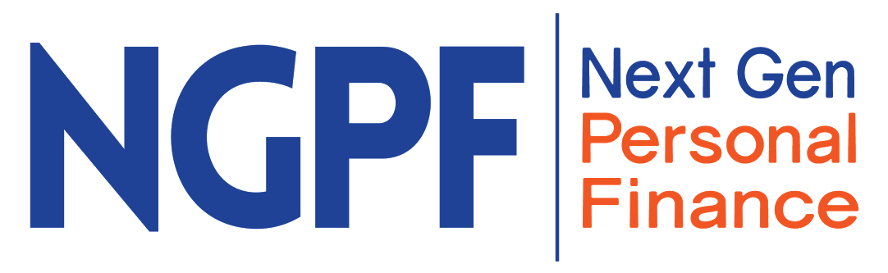
- Head to ngpf.org 2. Explore!
Curriculum Tab Qs | Curriculum Tab As
1. Which NGPF Course might fit best into the limited time you have to explore personal finance with your students?
2. Click on any of the courses or workshops that interest you, open up the Course Map or Workshop Map, and preview it. Do you have any questions you want to ask the facilitator about this? Note any to the right.
Head to Curriculum, then click Units, then pick ONE of the following: Paying For College, Careers, Budgeting or Bonus…
Unit Qs | Unit As
3. What is an Activity in this Unit you would consider using this term with your students?
4. Which Project in the Unit do you think your students would enjoy exploring most?
5. Does this Unit have any Fine Prints? If so, how would you use one with your students?
6. Which Question of the Day might you consider sending to one of your students?
7. How can you tell if an NGPF resource has been translated into (Sp)anish?

Resources Qs | Resources As
8. How many Activities are there in the Paying For College unit?
9. Which Case Study would you be most excited about using from the Career unit?
Community Qs | Community As
10. What Podcast episode would you be interested in listening to?
11. What recent Blog post would help boost your own content knowledge on Financial Literacy topics?

Teacher PD Tab Qs | Teacher PD Tab As
12. What options does NGPF offer for online PD?
13. Did you spot any upcoming PD options for counselors?
Advocacy Tab Qs | Advocacy Tab As
14. What is the name of NGPF’s Documentary promoting financial education for all high schoolers?
15. What is Mission: 2030?

Arcade Qs | Arcade As
17. What is one game you haven’t played yet that you want to come back to and play later?
18. What NGPF Arcade game(s) might make for a strong introduction to budgeting concepts?

