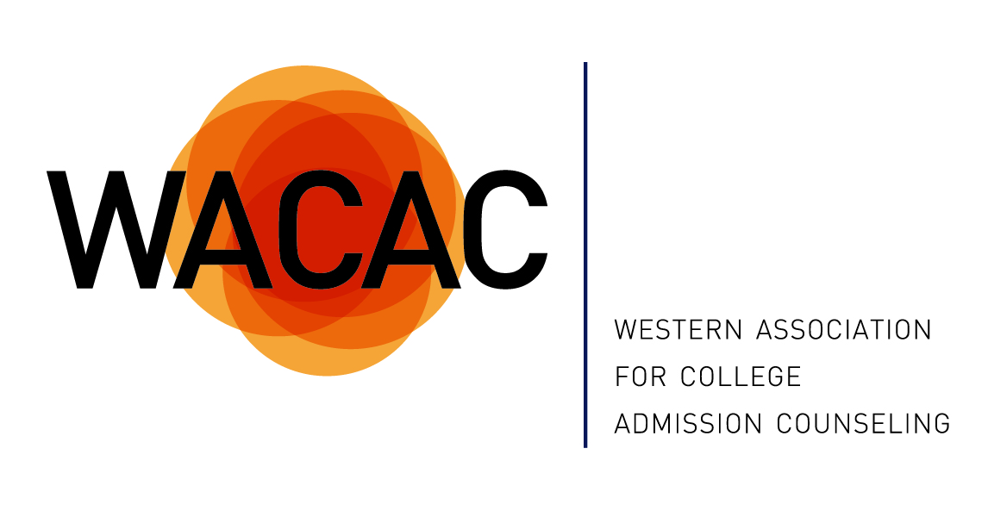
WACAC 2015 Conference Scholarship Application
Conference Details: The 2015 WACAC Annual Conference “SuperACAC II” will take place at the Atlantis Casino Resort & Spa in Reno, Nevada from Monday, May 18 – Wednesday, May 20.
Who can apply for this scholarship? You! Scholarships are limited. Priority will be given to counselors who serve students directly at public high schools, charter schools, non-profit or community-based organizations and community college transfer centers.
What does the scholarship pay for? Scholarships are available in two forms:
- Full Conference: Conference Registration for May 18 through May 20 and a stipend of $150 for lodging.
- One-Day Conference: Conference Registration for the Local Counselors’ Day on Tuesday, May 19th (no lodging).

Please note: Conference Scholarships do not include funds for transportation to/from the conference, meals outside of those offered in conjunction with the conference, incidentals, or Pre-Conference workshops.

What to expect? Scholarship Recipient you will be required to volunteer for 3 hours during the conference. Lodging stipend will not be provided until the volunteer hours have been completed.
Timeline:
February 10th: Scholarship Application Deadline
March 2nd: Scholarship Notifications
How to apply:
To apply for the WACAC Conference Scholarship, please complete the attached scholarship application in full. Please email your completed application to Sunday Salter saltersc@piercecollege.edu

2015 WACAC Conference Scholarship Application

Full Name:

Title:

Organization:

Mailing Address:

Email Address:

Phone #:

Are you applying for the Full Conference or 1-Day Conference Scholarship?
*Please note once scholarship has been awarded the value is not transferable.

Are you a member of WACAC?

Have you previously received a WACAC Conference Scholarship?

Have you ever attended an event sponsored by WACAC?
If yes, which events?

How long have you been in the counseling profession?

How many students do you serve?

Briefly describe the student population you serve.

What other professional growth opportunities have you attended? (UC Counselor Conference, etc.)

2015 WACAC Conference Scholarship Application
Page 2

What are you hoping to gain by attending this conference?

Any additional information you would like the scholarship committee to consider?

Please email completed applications to Sunday Salter saltersc@piercecollege.edu by the application deadline February 10th. If you are selected for a scholarship, you will be notified by email and given a special code for registration.

